Lab 3

presented to Eng. Mina Nagy
Name : Ebrahim Muhammed sabry

1 & 2 Create a user account with the following attribute
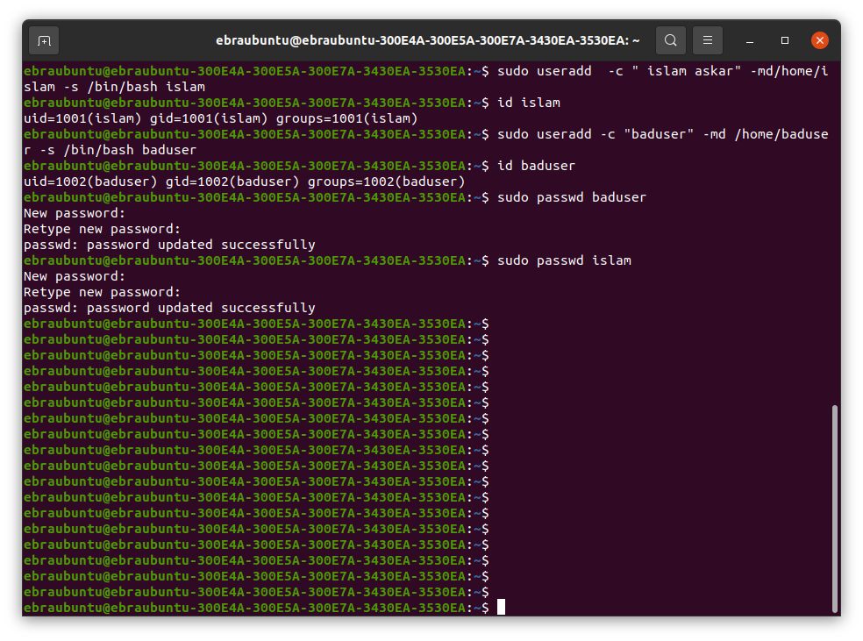
3. Create a supplementary (Secondary) group called pgroup with group ID of 30000

4,5,6,7,8
Create a supplementary group called badgroup
Add islam user to the pgroup group as a supplementary group
Modify the password of islam's account to password
Modify islam's account so the password expires after 30 days
Lock bad user account so he can't log in
